1. Frontend Development
-- Frontend is the part of a website that users can see and interact with.
-- It focuses on the design, layout, buttons, forms, and user interface.
-- Common technologies: HTML, CSS, JavaScript, React, Angular.
-- It directly interacts with the user.

Backend Development
--It focuses on server-side logic, databases, and data processing.
-- Common technologies: PHP, Java, Python, Node.js, MySQL, MongoDB.
-- It communicates with the database and server.

Full-Stack Development
--Full-Stack Development includes both frontend and backend development.
--A full-stack developer can build both the user interface and the server-side functionality.
-- Uses both frontend and backend technologies together.
--It manages both user interaction and server operations.

2.

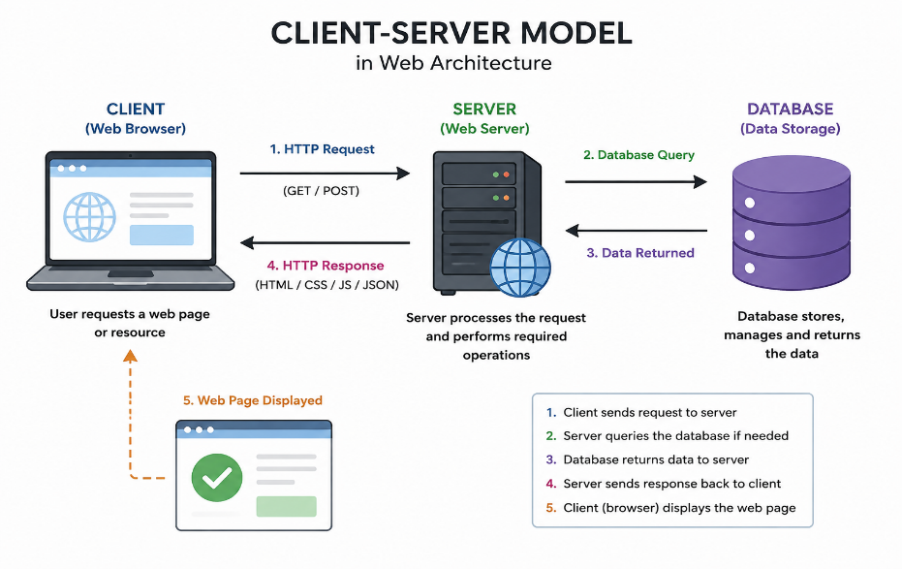
3. When a user enters a website address (URL) in a web browser, the browser sends a request to the web server to access the required web page. The web server processes the request and sends the requested files back to the browser. Finally, the browser renders and displays the web page to the user.
Steps:
- User Enters URL
  - The user types a website address (e.g., www.example.com) into the browser.
- Browser Sends HTTP Request
  - The browser sends an HTTP/HTTPS request to the web server asking for the requested web page.
- Web Server Processes the Request
  - The web server receives the request.
  - If required, it retrieves data from the database and processes the request.
- Server Sends HTTP Response
  - The server sends back an HTTP response containing HTML, CSS, JavaScript, images, and other required files.
- Browser Renders the Web Page
  - The browser interprets the received files and displays the complete web page on the user's screen.
Example:
Suppose a user visits www.amazon.com.
- The browser sends an HTTP request to Amazon's web server.
- The server processes the request and retrieves product information from the database.
- The server sends the webpage files to the browser.
- The browser displays the Amazon homepage with text, images, buttons, and other content.

4. To create and test a website, a web developer needs some basic tools. Each tool has a specific purpose.
Tool | Purpose
Code Editor (VS Code, Sublime Text) | Used to write and edit HTML, CSS, JavaScript, and other programming code.
Web Browser (Google Chrome, Microsoft Edge, Firefox) | Used to run and test web pages and check how they look to users.
Local Server (XAMPP, WAMP, Laragon) | Used to run websites on a local computer, especially websites that use PHP or databases.
Database (MySQL) | Used to store and manage website data such as user accounts, products, and records.
Version Control (Git) | Helps track changes in the code and allows developers to work together without losing previous versions.
GitHub | An online platform used to store code, share projects, and collaborate with other developers.
Package Manager (Node.js & npm) | Used to install and manage libraries and tools required for web development.
Browser Developer Tools | Used to inspect HTML, CSS, JavaScript, and debug errors in a web page.

5 . A web server is a software or computer that stores website files and delivers them to users when they request a web page through a web browser. It receives the browser's request, processes it, and sends back the required web page.
In simple words, a web server acts as a bridge between the browser and the website.
Examples of Commonly Used Web Servers:
- Apache HTTP Server – One of the most popular web servers used to host websites and web applications.
- Nginx – A fast and lightweight web server used for handling large numbers of users.
- Microsoft IIS (Internet Information Services) – A web server developed by Microsoft for Windows systems.
- LiteSpeed Web Server – A high-performance web server known for its speed and security.

6 . The Frontend Developer, Backend Developer, and Database Administrator (DBA) work together to build and maintain the website or application.
1. Frontend Developer
A frontend developer creates the part of the website that users can see and interact with. They design the layout, buttons, forms, menus, and ensure the website looks attractive and works properly on different devices.
Example: Creating the homepage, login page, and navigation menu of a website.
2. Backend Developer
A backend developer works on the server-side of the application. They write the business logic, handle user requests, connect the website with the database, and ensure the application works correctly.
Example: Processing user login, handling online payments, and saving user information.
3. Database Administrator (DBA)
A Database Administrator manages the database of the application. They store, organize, secure, and maintain data so that it can be accessed quickly and safely.
Example: Managing customer records, student details, and product information in the database.

7 . 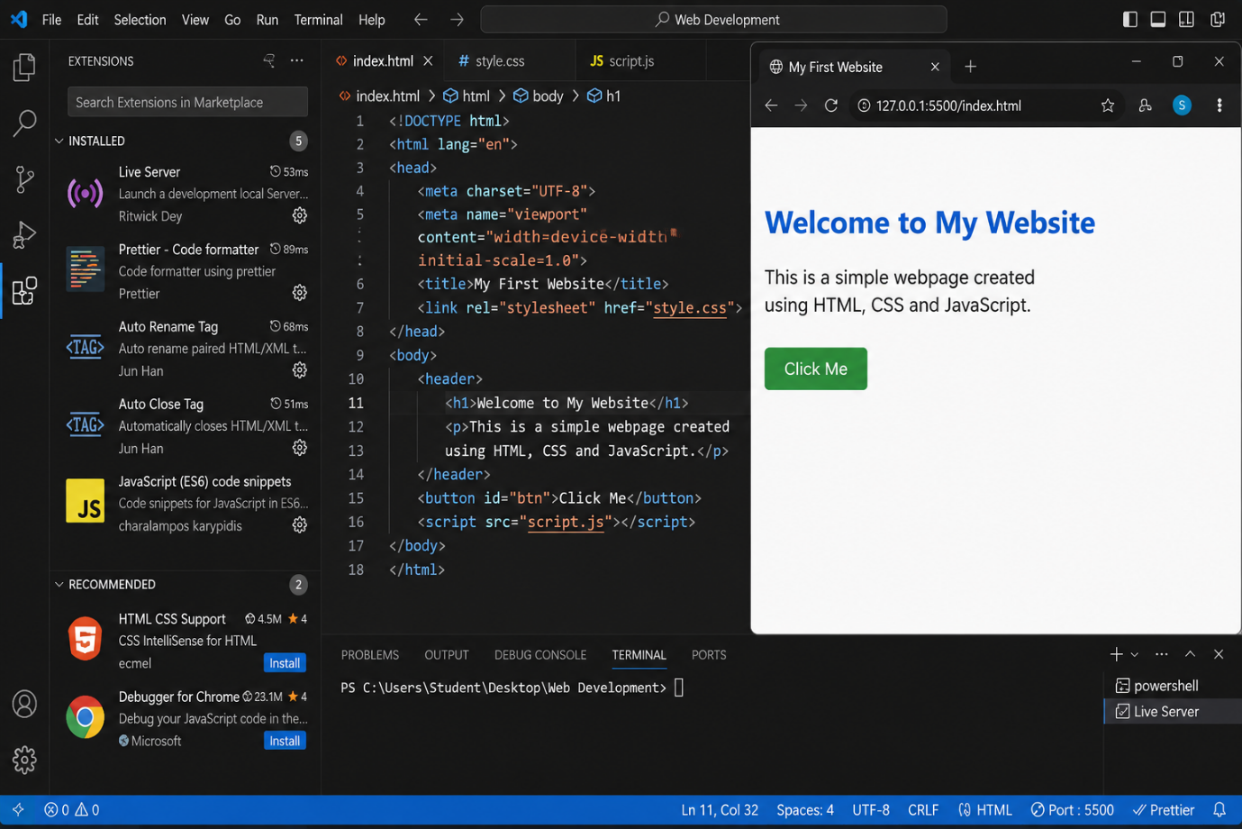

8. A static website is a website that displays the same content to every user. The content remains fixed and can only be changed by editing the website's source code. Static websites are simple, fast, and are mainly created using HTML and CSS. An example of a static website is a personal portfolio or a college information website.
A dynamic website is a website whose content changes according to the user's request, login details, or information stored in a database. These websites use server-side programming languages such as PHP, Python, or Node.js along with databases like MySQL. Dynamic websites are interactive and support features such as user login, online shopping, and search functionality. Examples of dynamic websites include Amazon, Facebook, and Instagram.

9 . A web browser is a software application that allows users to access and view websites on the Internet. Some of the most popular web browsers are Google Chrome, Mozilla Firefox, Microsoft Edge, Apple Safari, and Opera.
Each browser uses a rendering engine, which is responsible for reading HTML, CSS, and JavaScript code and displaying the web page on the screen. Different browsers use different rendering engines. Google Chrome, Microsoft Edge, and Opera use the Blink rendering engine, which is known for its speed and performance. Mozilla Firefox uses the Gecko rendering engine, developed by Mozilla, while Apple Safari uses the WebKit rendering engine, developed by Apple. Because different browsers use different rendering engines, the appearance and performance of a website may vary slightly across browsers.

10. 